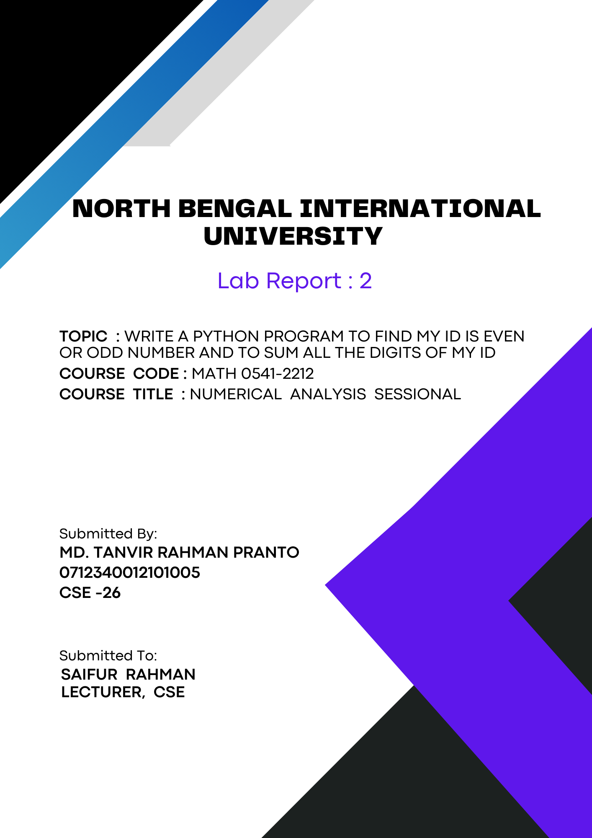
1

Theory: Python is a versatile, high-level programming language known for its simplicity and readability. Created by Guido van Rossum and first released in 1991, it emphasizes clear and concise syntax, making it an excellent choice for beginners and experienced developers alike. Python supports multiple programming paradigms.

Python Variables: In Python, a variable is like a name tag that you attach to a value to keep track of it. For example, if you want to store the number 10, you can use a variable like this: `x = 10`. Now, every time you use `x`, Python will know you're referring to the value 10. Variables can hold different types of values, such as numbers, words, or lists, and you can change what value they hold at any time. They make it easy to manage and use information in your program.

If-Else Statement: An if-else statement in programming allows you to make decisions based on conditions. If the condition is true, one block of code runs. If the condition is false, a different block of code runs. This helps the program choose different actions depending on what is happening. p is a way to repeat a block of code multiple times. It starts with an initial value, checks a condition, and updates the value each time the loop runs. The code inside the loop keeps running until the condition is no longer true. This makes it easy to repeat actions like going through a list of items.

Python program to find my id is even or odd number :
Algorithm:
1. Start.
2. Prompt the user to enter their ID number.
3. Read the input from the user and convert it to an integer.
4. Check if the ID number is even:
- Divide the ID number by 2.
- If the remainder is 0, the number is even.
5. Print the result:
- If the number is even, print "Your ID number is even."
- If the number is not even, print "Your ID number is odd."
6. End.

Code:
id_number = int(input("Enter your ID number: "))

if id_number % 2 == 0:
print("Your ID number is even.")
else:
print("Your ID number is odd.")
Output:
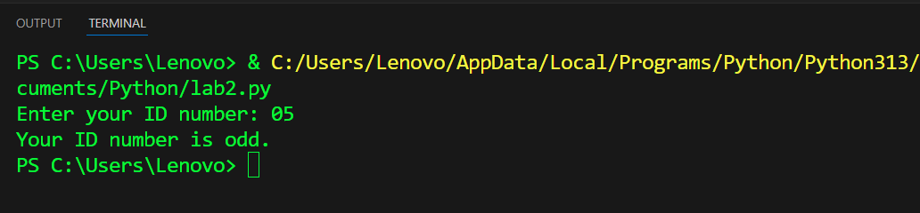

Python program to Sum all the digit of my id number :

Algorithm:
1. Start.
2. Prompt the user to enter their ID number.
3. Read the input from the user and store it as a string.
4. Initialize a variable `sum` to 0 to store the sum of the digits.
5. Loop through each character in the ID number string:
- Convert the character to an integer.
- Add the integer value to `sum`.
6. Print the sum of the digits.
7. End.

Code:
id_number = input("Enter your ID number: ")
sum = 0
for digit in id_number:
sum += int(digit)
print("The sum of the digits of your ID number is:", sum)

Output:
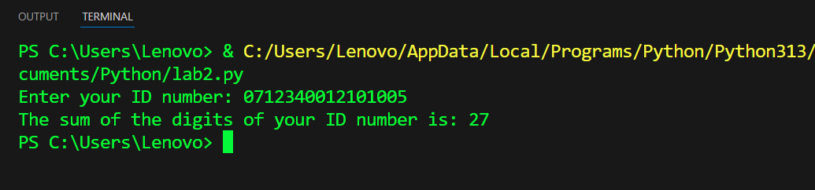

Conclusion: The two Python programs illustrate basic yet important concepts of handling user input and performing operations on it. The first program determines whether an ID number is even or odd by checking if it's divisible by 2. This example showcases the use of conditional statements to make decisions based on user input. The second program sums the digits of an ID number, demonstrating how to iterate through a string, convert its characters to integers, and perform arithmetic operations. Together, these programs provide a foundation for understanding input handling, loops, and conditionals in Python, which are crucial skills for any budding programmer.

